**Business in America**

**Too much of a good thing**

**Profits are too high. America needs a giant dose of competition**

Mar 26th 2016 | [From the print edition](http://www.economist.com/printedition/2016-03-26)

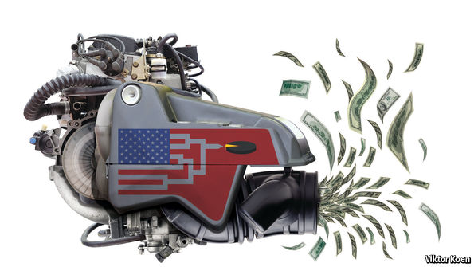

AMERICA’S airlines used to be famous for two things: terrible service and worse finances. Today flyers still endure hidden fees, late flights, bruised knees, clapped-out fittings and sub-par food. The profit bit of the picture, though, has changed a lot. Last year America’s airlines made $24 billion—more than Alphabet, the parent company of Google. Even as the price of fuel, one of airlines’ main expenses, collapsed alongside the oil price, little of that benefit was passed on to consumers through lower prices, with revenues remaining fairly flat. After a bout of consolidation in the past decade the industry is dominated by four firms with tight financial discipline and many shareholders in common. And the return on capital is similar to that seen in Silicon Valley.

What is true of the airline industry is increasingly true of America’s economy as a whole. Profits have risen in most rich countries over the past ten years but the increase has been biggest for American firms. Coupled with an increasing concentration of ownership, this means the fruits of economic growth are being hoarded. This is probably part of the reason that two-thirds of Americans, including a majority of Republicans, have come to believe that the economy “unfairly favours powerful interests”, according to polling by Pew, a research outfit. It means that when Hillary Clinton and Bernie Sanders, the Democratic contenders for president, say that the economy is “rigged”, they have a point.

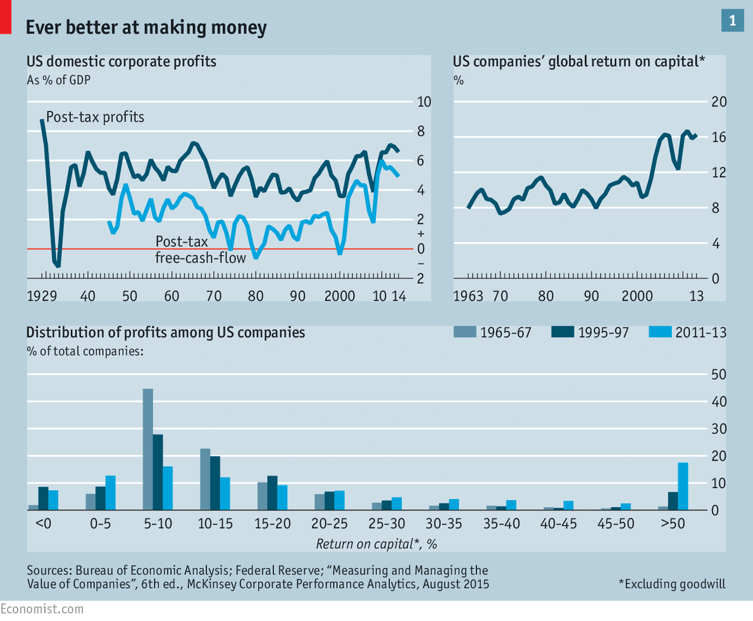

The last year has seen a slight dip in aggregate profits because of the high dollar and the effect of the oil price on energy firms. But profits are at near-record highs relative to GDP (see chart 1) and free cash flow—the money firms generate after capital investment has been subtracted—has grown yet more strikingly. Return on capital is at near-record levels, too (adjusted for goodwill). The past two decades have seen most firms make more money than they used to. And more firms have become very profitable.

Opportunities

An intense burst of consolidation will boost their profits more. Since 2008 American firms have engaged in one of the largest rounds of mergers in their country’s history, worth $10 trillion. Unlike earlier acquisitions aimed at building global empires, these mergers were largely aimed at consolidating in America, allowing the merged companies to increase their market shares and cut their costs. The companies in question usually make no pretence of planning to pass the savings they make this way on to their customers; take their estimates of the synergies involved at face value and profits in America will rise by a further 10% or so.

Profits are an essential part of capitalism. They give investors a return, encourage innovation and signal where resources should be invested. Their accumulation allows investment in bold new ventures. Countries where profits are too low—Japan, for instance—can slip into morbid torpor. Firms that ignore profits, such as China’s state-run enterprises, lurch around like aimless zombies, as likely to destroy value as to create it.

But high profits across a whole economy can be a sign of sickness. They can signal the existence of firms more adept at siphoning wealth off than creating it afresh, such as those that exploit monopolies. If companies capture more profits than they can spend, it can lead to a shortfall of demand. This has been a pressing problem in America. It is not that firms are underinvesting by historical standards. Relative to assets, sales and GDP, the level of investment is pretty normal. But domestic cash flows are so high that they still have pots of cash left over after investment: about $800 billion a year.

High profits can deepen inequality in various ways. The pool of income to be split among employees could be squeezed. Consumers might pay too much for goods. In a market the size of America’s prices should be lower than in other industrialised economies. By and large, they are not. Though American companies now make a fifth of their profits abroad, their naughty secret is that their return-on-equity is 40% higher at home.

Most explanations of America’s high profits draw on national-accounts data which show that the fall in the share of output going to workers over the past decade is equivalent to about 60% of the rise in domestic pre-tax profits. Scholars typically have three explanations for this: technology, which has allowed firms to replace workers with machines and software; globalisation, which has made it easier to shift production to lower cost countries; and a decline in trade-union membership.

None of these accounts, though, explain the most troubling aspect of America’s profit problem: its persistence. Business theory holds that firms can at best enjoy only temporary periods of “competitive advantage” during which they can rake in cash. After that new companies, inspired by these rich pickings, will pile in to compete away those fat margins, bringing prices down and increasing both employment and investment. It’s the mechanism behind Adam Smith’s invisible hand.

In America that hand seems oddly idle. An American firm that was very profitable in 2003 (one with post-tax returns on capital of 15-25%, excluding goodwill) had an 83% chance of still being very profitable in 2013; the same was true for firms with returns of over 25%, according to McKinsey, a consulting firm. In the previous decade the odds were about 50%. The obvious conclusion is that the American economy is too cosy for incumbents.

In 1998, Joel Klein, who ran the antitrust operation at the Department of Justice (DoJ), declared that “our economy is more competitive today than it has been in a long, long time.” He may well have been right. In the post-war boom American firms grew into mighty conglomerates; in the 1960s J.K. Galbraith, a left-leaning economist, predicted the rise of a symbiotic “industrial state” in which large companies worked closely with the government. But in the 1980s deregulation opened some industries, such as telecoms and railways, to competition. And a new doctrine of shareholder value led big firms, such as RJR Nabisco, to be broken-up and sprawling conglomerates to become focused. In the 1990s American firms faced a wave of competition from low-cost competitors abroad (and, reciprocally, focused their energy on expanding overseas).

Since then the pendulum seems to have swung back. Huge companies, long the focus of American worries about competition, have not actually got any bigger. In 2014 the top 500 listed firms made about 45% of the global profits of all American firms, as they did in the late 1990s. Instead they, and other companies, have become more focused. The strategy can be seen as an amalgam of the philosophies of two deeply influential business figures. Jack Welch, the boss of General Electric for two decades at the end of the 20th century, advised companies to get out of markets which they did not dominate. Warren Buffett, the 21st century’s best-known investor, extols firms that have a “moat” around them—a barrier that offers stability and pricing power.

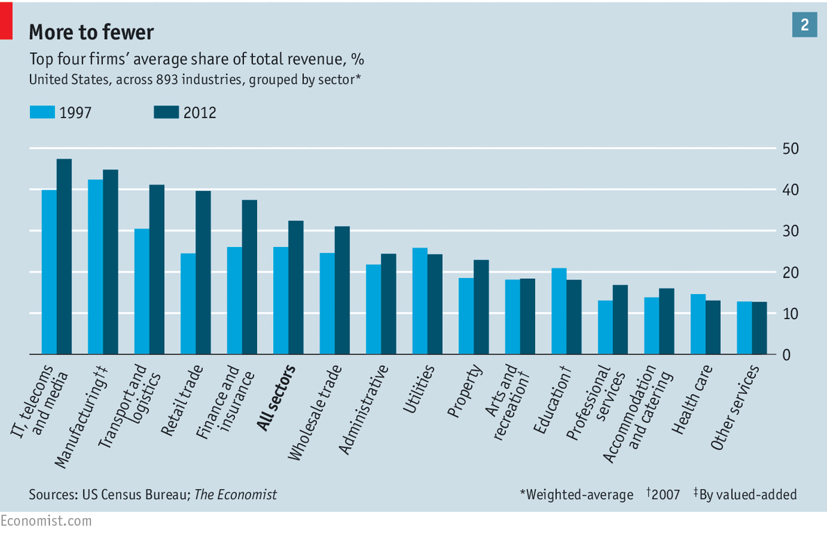

One way American firms have improved their moats in recent times is through creeping consolidation. *The Economist* has divided the economy into 900-odd sectors covered by America’s five-yearly economic census. Two-thirds of them became more concentrated between 1997 and 2012 (see charts 2 and 3). The weighted average share of the top four firms in each sector has risen from 26% to 32%.

[[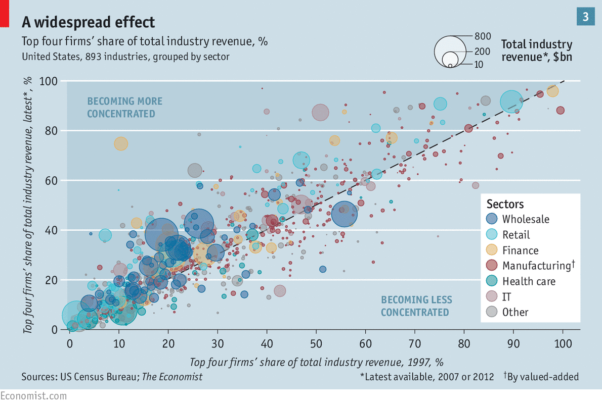](http://www.economist.com/blogs/graphicdetail/2016/03/daily-chart-13)](http://www.economist.com/blogs/graphicdetail/2016/03/daily-chart-13)

[INTERACTIVE: Explore all 893 industries grouped by sector in our interactive scatter chart](http://www.economist.com/blogs/graphicdetail/2016/03/daily-chart-13)

Miracles

These data make it possible to distinguish between sectors of the economy that are fragmented, concentrated or oligopolistic, and to look at how revenues have fared in each case. Revenues in fragmented industries—those in which the biggest four firms together control less than a third of the market—dropped from 72% of the total in 1997 to 58% in 2012. Concentrated industries, in which the top four firms control between a third and two-thirds of the market, have seen their share of revenues rise from 24% to 33%. And just under a tenth of the activity takes place in industries in which the top four firms control two-thirds or more of sales. This oligopolistic corner of the economy includes niche concerns—dog food, batteries and coffins—but also telecoms, pharmacies and credit cards.

Concentration does not of itself indicate collusion. Other factors at play might include regulations that keep competitors out. Business spending on lobbying doubled over the period as incumbents sought to shape regulations in ways that suited them. The rising importance of intangible assets, particularly patents, has meant that an ability to manage industry regulators and the challenges of litigation is more valuable than ever.

The ability of big firms to influence and navigate an ever-expanding rule book may explain why the rate of small-company creation in America is close to its lowest mark since the 1970s (although an index of startups run by the Kauffman Foundation has shown flickers of life recently). Small firms normally lack both the working capital needed to deal with red tape and long court cases, and the lobbying power that would bend rules to their purposes. A lack of lobbying clout and legal savvy may also help explain foreign firms’ loss of momentum. In the 1990s adventurers from abroad piled into America, with the share of output from foreign-owned subsidiaries rising steadily. But foreign firms seem to have lost their mojo. Since 2003 their contribution has been flat at about 6% of private business output.

Another factor that may have made profits stickier is the growing clout of giant institutional shareholders such as BlackRock, State Street and Capital Group. Together they own 10-20% of most American companies, including ones that compete with each other. Claims that they rig things seem far-fetched, particularly since many of these funds are index trackers; their decisions as to what to buy and sell are made for them. But they may well set the tone, for example by demanding that chief executives remain disciplined about pricing and restraining investment in new capacity. The overall effect could mute competition.

Quantifying the effect of the corporate America’s defences is tricky. Profits are not the whole picture. In some industries—banking is a case in point—rent-seeking will result in high pay to an employee elite instead. But one can get a crude sense of what is going on by dividing the profits all firms generate into the “bog-standard” and the “exceptional”. Over the past 50 years return on capital has averaged about 10% (excluding goodwill) and that is what investors tend to demand, so let that represent bog-standard profits. The excess on top of that—which may reflect brilliant innovations, wise historic investments in intangible assets such as brands, or, perhaps, a lack of competition—is the exceptional bit. For S&P 500 firms these exceptional profits are currently running at about $300 billion a year, equivalent to a third of taxed operating profits, or 1.7% of GDP.

I love you, you pay my rent

About a quarter of America’s abnormal profits are spread across a wide range of sectors. Returns on capital, concentration and prices have risen in many pockets of the economy. The cable television industry has become more tightly controlled, and many Americans rely on a monopoly provider; prices have risen at twice the rate of inflation over the past five years. Consolidation in one of Mr Buffett’s favourite industries, railroads, has seen freight prices rise by 40% in real terms and returns on capital almost double since 2004. The proposed merger of Dow Chemical and DuPont, announced last December, illustrates the trend to concentration. After combining, the companies plan to split into three specialist companies each of which will have a higher share of its market than either original company had before the deal. They say the plan will yield $3 billion in cost savings. Since 2008 American mergers have sought to remove recurring annual costs of about $150 billion from industrial ledgers. Few firms that are not regulated utilities have public plans to pass these gains on to consumers.

Concentration is contagious. As firms become more powerful those elsewhere on associated chains of customers and suppliers bulk up in response. Google now dominates internet searches for flights and hotels. This has led Expedia, the leading internet travel-agent, to beef up by buying two of its main rivals over the past two years. The spectre of very big online travel sites dominating the purchase of hotel rooms has led the hotel firms to consolidate, too, with Marriott agreeing to buy Starwood this month. (A Chinese firm, Anbang, may make a counter-bid).

Roughly another quarter of abnormal profits comes from the health-care industry, where a cohort of pharmaceutical and medical-equipment firms make aggregate returns on capital of 20-50%. The industry is riddled with special interests and is governed by patent rules that allow firms temporary monopolies on innovative new drugs and inventions. Much of health-care purchasing in America is ultimately controlled by insurance firms. Four of the largest, Anthem, Cigna, Aetna and Humana, are planning to merge into two larger firms.

The rest of the abnormal profits are to be found in the technology sector, where firms such as Google and Facebook enjoy market shares of 40% or more. By Silicon Valley’s account such penetration reflects the popularity and inventiveness of the products on offer, some of which are free to consumers. Today’s dominant firms could be tomorrow’s Nokia or Blackberry: Apple now trades on just 11 times earnings, suggesting investors expect it to decline. Firms such as Uber and Airbnb are a rare source of disruption in the economy, competing fiercely with incumbents.

But many of these arguments can be spun the other way. Alphabet, Facebook and Amazon are not being valued by investors as if they are high risk, but as if their market shares are sustainable and their network effects and accumulation of data will eventually allow them to reap monopoly-style profits. (Alphabet is now among the biggest lobbyists of any firm, spending $17m last year.) A fall from grace in the tech world is not as bad as you might imagine. Microsoft’s operating profits today are twice what they were in 2000, when Mr Klein was prosecuting it in an antitrust trial. And the “sharing economy” startups that are being so highly rated by some investors mostly seek to dominate their markets. The large mountains of cash they are burning today can only be justified if they eventually mature to enjoy very high market shares and margins.

In the past, periods of high and stable profits have ended. Just three years after Mr Galbraith made his 1967 prediction of a cosy, collaborative business world, it was already toast: profits had collapsed by a third relative to GDP as recession struck. Today’s profits, too, may be more vulnerable than they look. If wages finally pick up it could crimp margins. The earnings-per-share of listed firms have fallen slightly in the past few quarters, though a strong dollar and declining oil revenues explain much of that. Some observers of the stockmarket argue that it is already signalling more decline. The gap between the real yield on equities and that on government bonds suggests that either firms are riskier than ever, bond yields are freakishly low, or that profits face a cyclical downturn.

Even so, it is hard to identify a mechanism by which profits might fall to more normal levels. Investors and managers continue to place extraordinarily high profit multiples on businesses with “moats”. The cable television industry is supposedly under pressure from the likes of Netflix and Amazon Prime. Yet in 2015 Charter Communications, a cable company, bought Time Warner Cable for $79 billion, or 26 times its free cash flow, which implies that it believes it will be in a position to raise prices. When Heinz (part-controlled by Mr Buffett) bought Kraft Foods in 2015, it paid 31 times the free cash flow and promptly slashed spending to boost margins, suggesting it felt the threat from rival makers of cheese slices was rather small.

Antitrust, but verify

Perhaps antitrust regulators will act, forcing profits down. The relevant responsibilities are mostly divided between the DoJ and the Federal Trade Commission (FTC), although some industries, such as railways and telecoms, also have their own regulators. The DOJ and FTC are busy trying to police the mergers-and-acquisition boom. Rather than contest every deal they select cases that set new precedents and argue them in court: of the 15,000 deals between 2005-14, about 3% have been subject to close scrutiny.

Together the two bodies have roamed far and wide. The DoJ has blocked domestic deals, such as the takeover by AT&T of T-Mobile USA in 2011, and cross-border combinations that would have caused concentration in global industries, such as the merger of two chipmakers, Applied Materials and Tokyo Electron, in 2015. The FTC spends a big chunk of its time looking at health care. It has blocked hospital mergers and fought “pay-for-delay” deals in which pharmaceutical firms try to stop generic competitors from launching rival products when patents expire. The DoJ is casting a beady eye over the airlines.

Yet the system suffers two limitations. One is constitutional. The two bodies’ job is to police infringements of a well-established and mature body of law through the courts. This leaves them admirably free of overt political interference and lobbying but it also limits their scope. Lots of important subjects are beyond their purview. They cannot consider whether the length and security of patents is excessive in an age when intellectual property is so important. They may not dwell deeply on whether the business model of large technology platforms such as Google has a long-term dependence on the monopoly rents that could come from its vast and irreproducible stash of data. They can only touch upon whether outlandishly large institutional shareholders with positions in almost all firms can implicitly guide them not to compete head on; or on why small firms seem to be struggling. Their purpose is to police illegal conduct, not reimagine the world. They lack scope.

The second limitation is intellectual. America’s antitrust apparatus has gone through periods of leniency (1915-35) and stridency (1936-72). By the 1980s the Chicago school of free-market thought was ascendant. Its insistence that the efficiency benefits of big mergers should not be dismissed had a big influence on the courts. Antitrust guidelines which held that any deal involving a firm with a market share of 35% or more should be considered suspect on principle have been set aside in favour of a more granular approach, with regulators looking ever more closely at the specific effects of a deal. To work out if a deal lowers consumers’ level of choice or lets firms hike prices they will study micro-markets in specific regions.

Who does not prefer the rifle to the blunderbuss, the scalpel to the axe? Such sophistication allows regulators to demand clever remedies, such as the disposal of subsidiaries. But with their heads deep in data and court rulings that set fine precedents, the scientists of antitrust are able to sidestep some troubling questions. If markets are truly competitive, why do so many companies now claim they can retain the cost synergies that big deals create, not pass them on to consumers? Why do investors believe them? Why have returns on capital risen almost everywhere?

These legal and intellectual limitations of the antitrust apparatus raise the question of competition to the political sphere—currently, alas, a realm well supplied with blunderbusses and axes wielded haphazardly and at the wrong targets. Americans’ mistrust of their economic system and the companies that make so much money in it has so far been channelled into calls for protectionism and government intervention. Free trade should be limited. Health-care firms should be more regulated. Foreign firms—particularly Chinese ones—should be discriminated against. Wages should be forced up. Taxes on companies should be raised.

Memories of the future

Nowhere has the alternative approach been articulated. It would aim to unleash a burst of competition to shake up the comfortable incumbents of America Inc. It would involve a serious effort to remove the red tape and occupational-licensing schemes that strangle small businesses and deter new entrants. It would examine a loosening of the rules that give too much protection to some intellectual-property rights. It would involve more active, albeit cruder, antitrust actions. It would start a more serious conversation about whether it makes sense to have most of the country’s data in the hands of a few very large firms. It would revisit the entire issue of corporate lobbying, which has become a key mechanism by which incumbent firms protect themselves.